Project Report: TCP/IP Layer Simulation
TCP/IP Layer Simulation: Connecting Bank Branches with Multiple Departments in GNS3
Student Name: [Your Name] Student ID: [Your ID] Date: December 1, 2025

1. Introduction & Network Scenario
This project involves the design and simulation of an enterprise network for a bank consisting of two branches: Branch A and Branch B. The goal was to establish connectivity between geographically separated departments using a WAN link, configure TCP/IP addressing, implement OSPF routing, and analyze network traffic at different layers of the OSI model.
Network Topology: The network topology was designed in GNS3 using Cisco c7200 routers, Ethernet switches, and Virtual PCs (VPCS).
- Branch A contains the HR and IT departments.
- Branch B contains the Sales and CS (Customer Service) departments.
- The branches are connected via a serial WAN link using the 10.0.0.0/30 subnet.

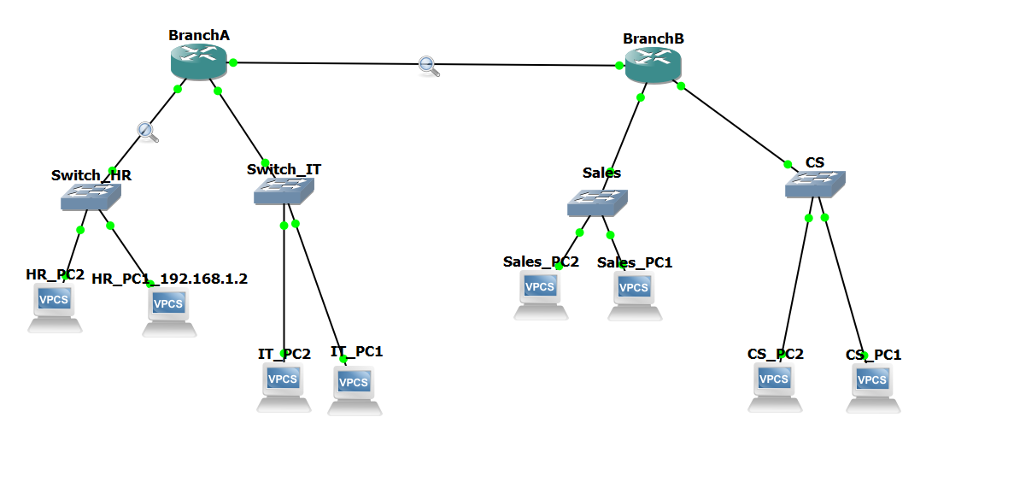

2. IP Addressing and Routing Configuration (Task 1)

2.1 IP Addressing Scheme
We utilized a hierarchical IP addressing scheme to segregate departments into different broadcast domains (subnets).
Device | Interface | IP Address | Subnet Mask | Description
Branch A Router | FastEthernet0/0 | 10.0.0.1 | 255.255.255.252 | WAN Link to Branch B
 | GigabitEthernet1/0 | 192.168.1.1 | 255.255.255.0 | Gateway for HR Dept
 | GigabitEthernet2/0 | 192.168.2.1 | 255.255.255.0 | Gateway for IT Dept
Branch B Router | FastEthernet0/0 | 10.0.0.2 | 255.255.255.252 | WAN Link to Branch A
 | GigabitEthernet1/0 | 192.168.3.1 | 255.255.255.0 | Gateway for Sales Dept
 | GigabitEthernet2/0 | 192.168.4.1 | 255.255.255.0 | Gateway for CS Dept
HR_PC1 | NIC | 192.168.1.2 | 255.255.255.0 | Host in Branch A
Sales_PC1 | NIC | 192.168.3.2 | 255.255.255.0 | Host in Branch B

2.2 Routing Configuration
To enable communication between the disjointed subnets, we configured OSPF (Open Shortest Path First) dynamic routing. This allowed the routers to exchange network information automatically.
Configuration Snippet (Router Branch A):
router ospf 1
network 192.168.1.0 0.0.0.255 area 0
network 192.168.2.0 0.0.0.255 area 0
network 10.0.0.0 0.0.0.3 area 0

3. TCP/IP Traffic Simulation (Task 2)

3.1 ICMP Traffic Simulation (Ping)
To verify end-to-end connectivity, we generated ICMP Echo Requests from HR_PC1 (Branch A) to Sales_PC1 (Branch B).
- Source: 192.168.1.2
- Destination: 192.168.3.2
- Result: Successful replies were received with an average TTL of 62, confirming the packet traversed two routers.
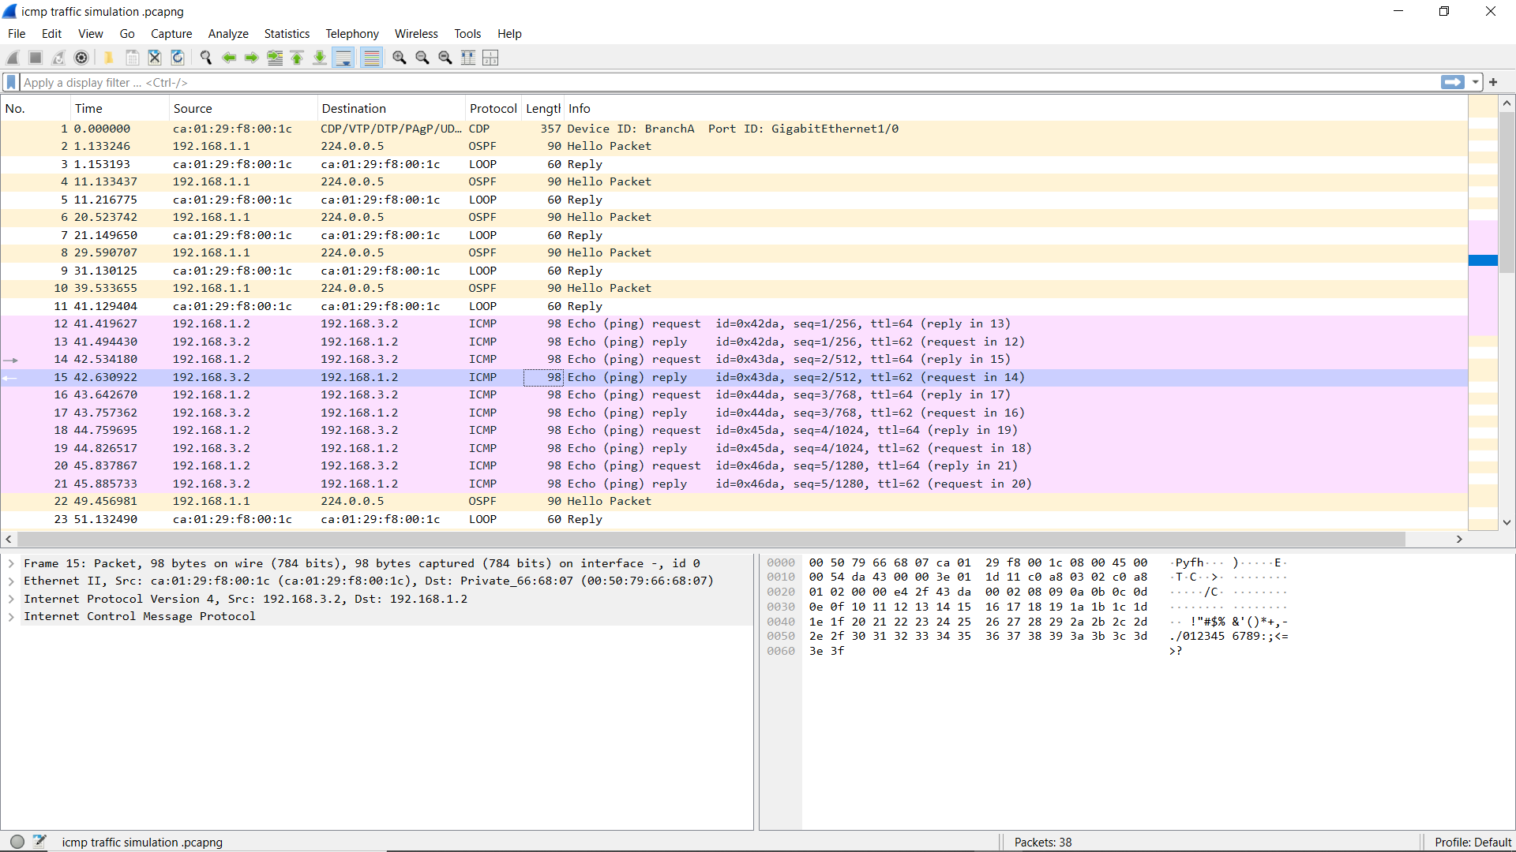

3.2 TCP Traffic Simulation (Telnet)
To simulate Transport Layer traffic, we initiated a Telnet session from Branch A router to Branch B router (10.0.0.2).
- Observation: The connection was successfully established (3-Way Handshake), but the session was closed by the remote host because no VTY password was set. This successfully demonstrated the TCP connection establishment process.
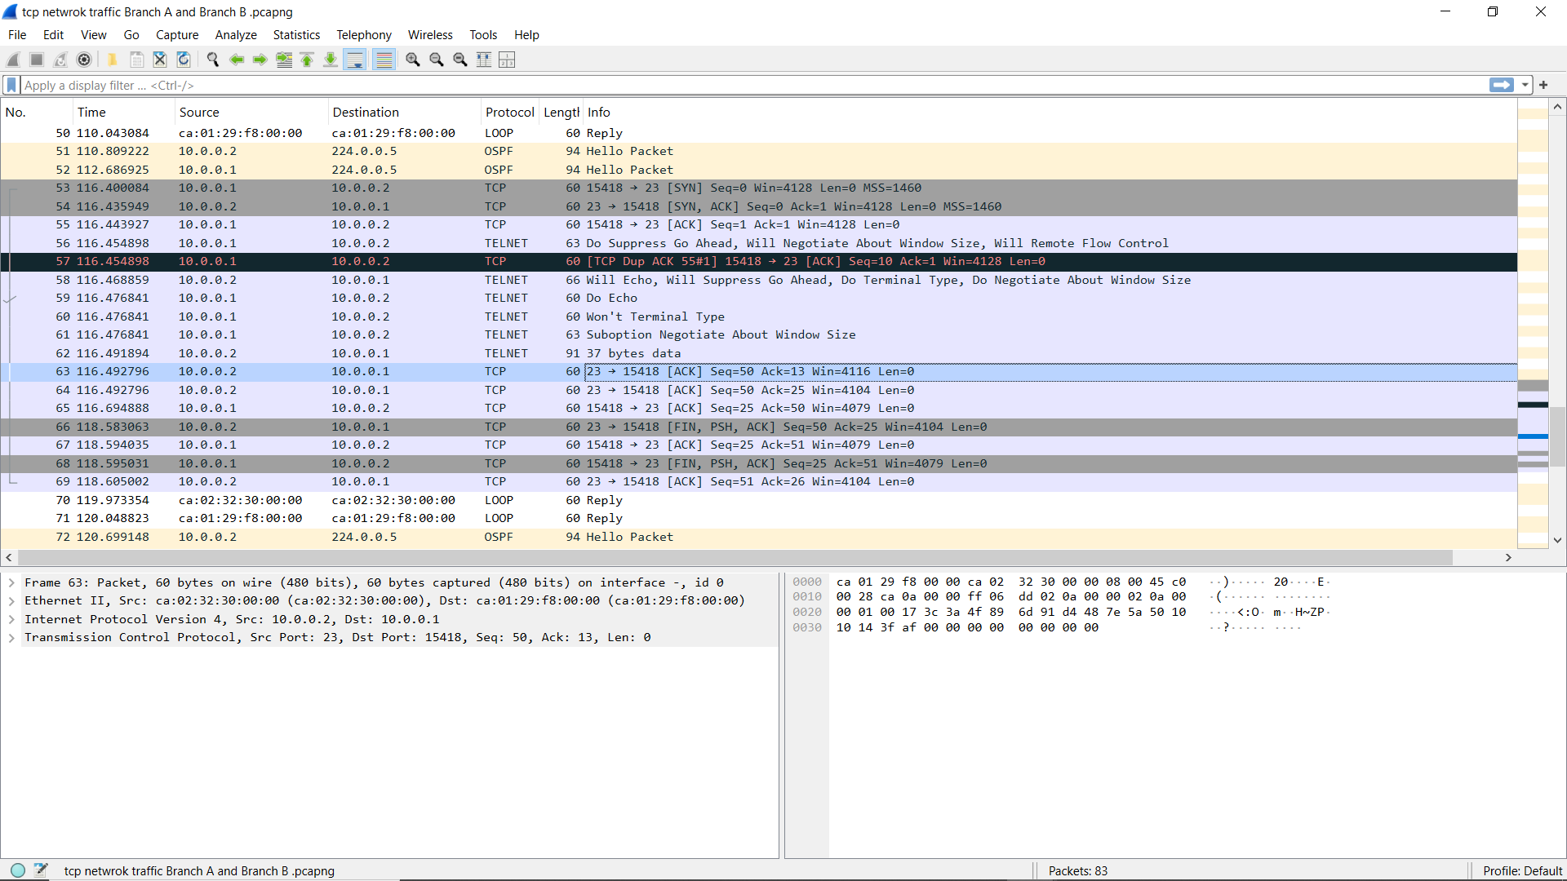

4. Packet Encapsulation Analysis (Task 3)
For this analysis, we selected Packet #58 from the TCP capture (a Telnet negotiation packet) to inspect the encapsulation headers at each layer of the TCP/IP model.

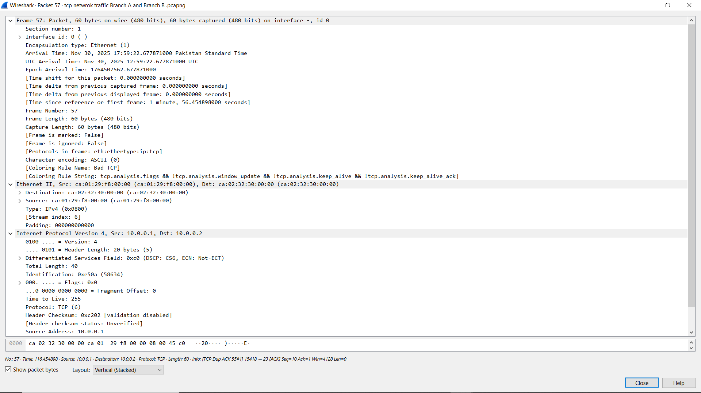

Layer Analysis Table
TCP/IP Layer | Header Field | Value (From Capture) | Explanation
Data Link (L2) | Source MAC | ca:02:32:30:00:00 | Physical address of Branch B Router (Sender).
 | Dest MAC | ca:01:29:f8:00:00 | Physical address of Branch A Router (Next Hop).
Network (L3) | Source IP | 10.0.0.2 | Logical address of the originating device.
 | Dest IP | 10.0.0.1 | Logical address of the receiving device.
 | Protocol | TCP (6) | Indicates the payload is for the Transport Layer.
Transport (L4) | Source Port | 15418 | Ephemeral port dynamically assigned to the client.
 | Dest Port | 23 | Well-known port for the Telnet service.
 | Seq Number | 10 | Used to reassemble data segments in order.
Application (L7) | Payload | Telnet Commands | Data: "Will Echo", "Suppress Go Ahead".

5. Observations and Conclusion
Observations:
- OSPF Convergence: Upon configuring OSPF, we observed the adjacency state change from LOADING to FULL in the console, indicating successful route exchange.
- ARP Resolution: Initial pings had a slight delay or packet loss (80% success rate) as the routers performed ARP requests to map IP addresses to MAC addresses. Subsequent pings were 100% successful.
- Security Layers: The Telnet simulation demonstrated that while the Network Layer (IP) and Transport Layer (TCP) successfully delivered the data, the Application Layer enforced security (closing the connection due to missing passwords).
Challenges Faced & Lessons Learned:
- Interface Identification: One challenge was identifying the correct interface slots on the virtual routers (Gi2/0 vs Gi1/2). I resolved this using the show ip interface brief command to verify available ports.
- Visual vs. Logical Connectivity: I learned that while GNS3 shows green link lights for connected cables, network connectivity (Ping) only works after configuring IP addresses and "no shutdown" commands.
- Encapsulation: By expanding the packet details in Wireshark, I gained a practical understanding of how data is encapsulated, with each layer adding specific headers (MAC, IP, Ports) to ensure delivery.

